<Greater Credit Portal>
Deployment Document
Version 1.0
25/03/2018

Version | Description of Change | Author | Date
1.0.0 | Document initial | Brandon.Zhang | 3-25-2019
1.0.0 | Add “7.9.Create a new database in SQL Server 2016” | Brandon.Zhang | 4-4-2019

Table of Contents
1. Introduction 4
2. Install Software 5
2.1. Download JDK 5
2.2. Install JDK 7
2.3. Set JDK environment 9
2.4. Download Tomcat server 14
2.5. Install Tomcat Server 15
3. Initial Project Data 19
3.1. Create Schema 20
3.2. Initial table data 21
3.3. Create Trigger 22
3.4. Copy file 23
4. Deploy 24
4.1. Stop the tomcat service 24
4.2. Copy deployed war 25
4.3. Start the tomcat service 25
4.4. System Login 26
5. Re-Deploy 27
5.1. Update DB data 27
5.2. Update WAR 27
6. Deploy Schedule Applications 28
6.1. Deploy Monthly Report Schedule Task 28
6.2. Deploy Housekeeping Schedule Task 29
7. Appendix 30
7.1. Set the properties for AD Login 30
7.2. Set MS SQL Server Data Source 31
7.3. Monthly Upgrade Customer List Report Directory 32
7.4. Monthly Downgrade Customer List Report Directory 33
7.5. Monthly Risk Migration Report Directory 34
7.6. Set Housekeeping Task directory 35
7.7. Set Housekeeping Task Running Log directory 36
7.8. Set Monthly Report Running Log directory 37
7.9. Create a new database in SQL Server 2016 38

Introduction
This document describes how to set up the environment and deploy the service.
The service will run on Window Server 2016 and requires DB server of MS SQL Server 2016.
The chapter 2 will instruct how to install the relative software, include Java and Tomcat.
The chapter 3 shows how to initial the DB data. It doesn’t include the DB server installation and the creation of new database. You also refer to 7.9.Create a new database in SQL Server 2016.
The chapter 4 tells how to deploy the service and run it.

The list of the environment:
Name | Version | Note
Operating System | Window Server 2016 | Install by customer
Database | SQL Server 2016 | Prepare by customer.  DB Server is not mandatory, but a database is mandatory
Runtime Engine | Java SE Development Kit 8u201
Application Server | Tomcat 8.5.39

Install Software
The project is developed by Java and it is run on Web Application Server. It requires install Java and Tomcat. This chapter shows how to install and the configuration.

Download JDK

Browse to URL: https://www.oracle.com/technetwork/java/javase/downloads/jdk8-downloads-2133151.html

Click the Accept license agreement radio button and the download icon in red box as the figure
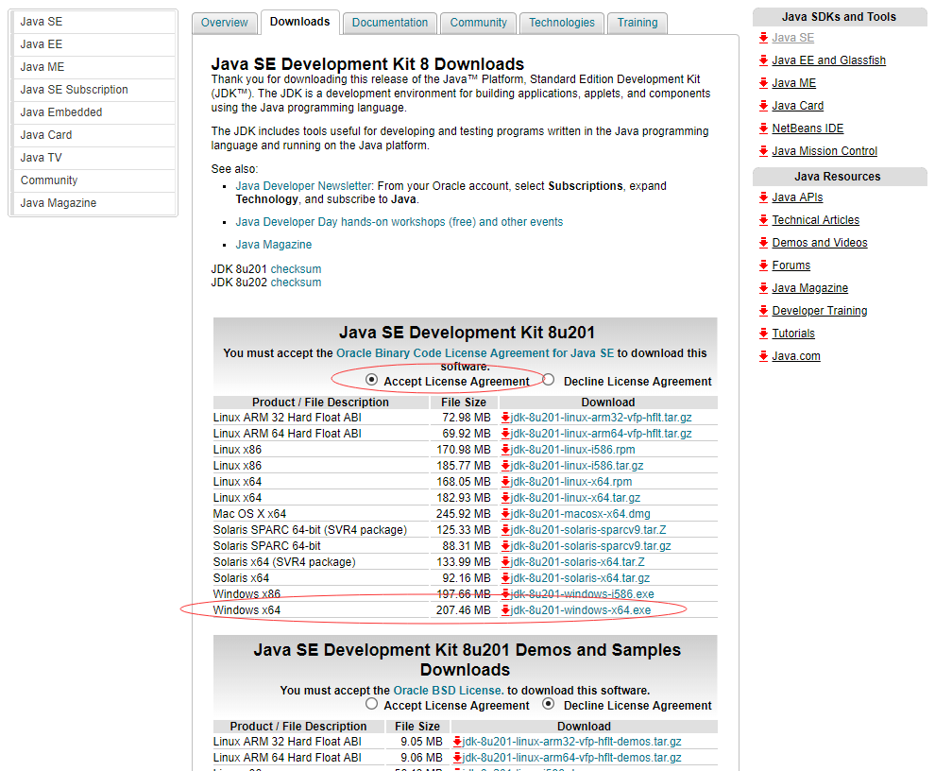
(x86 is for 32bit, x64 is for 64bit OS)

Install JDK

Click the downloaded file to start the installation
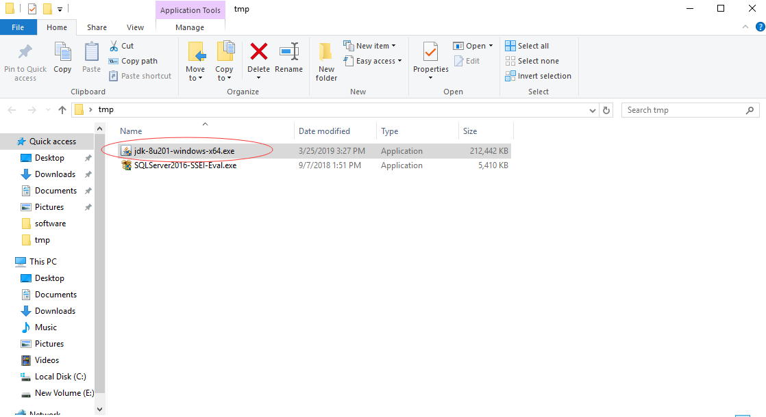

Click the next button to install the JDK to default path
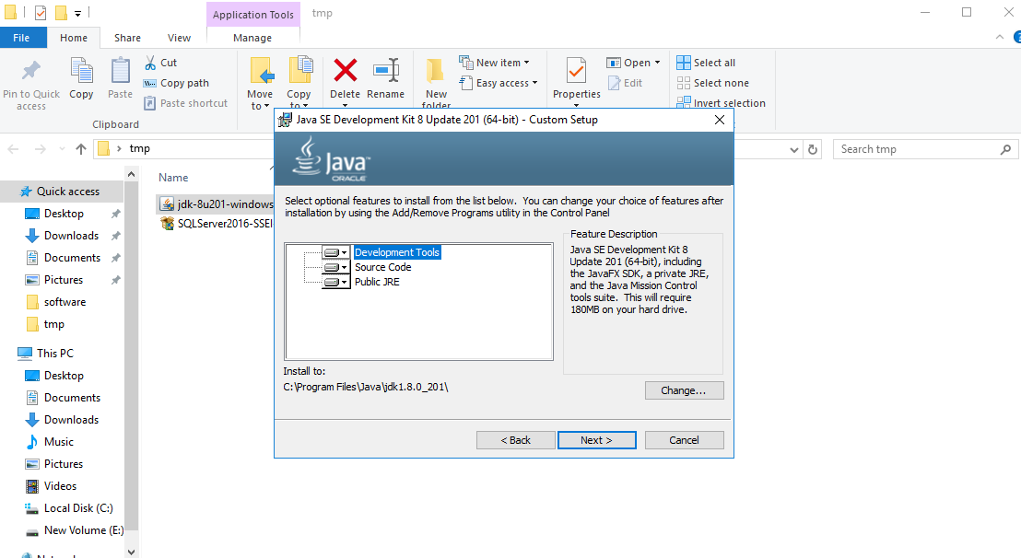

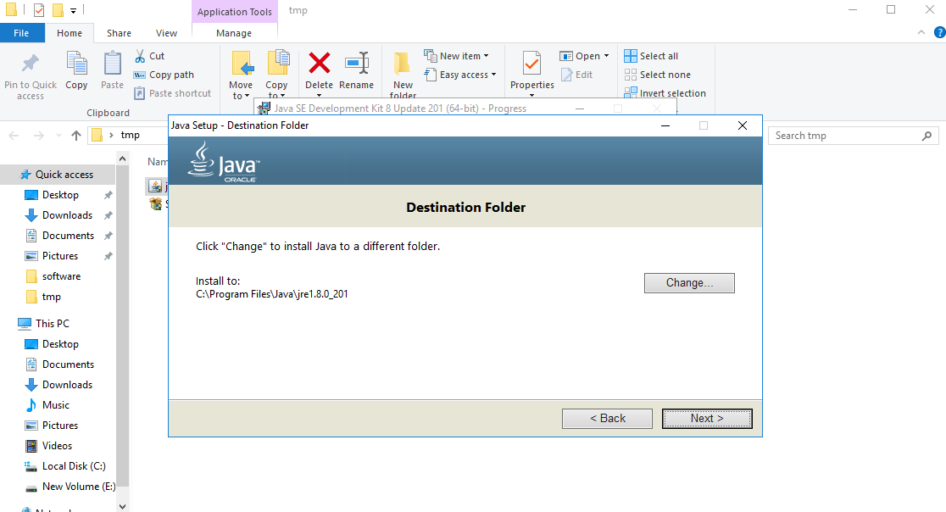

Set JDK environment

Right click This PC, click Properties
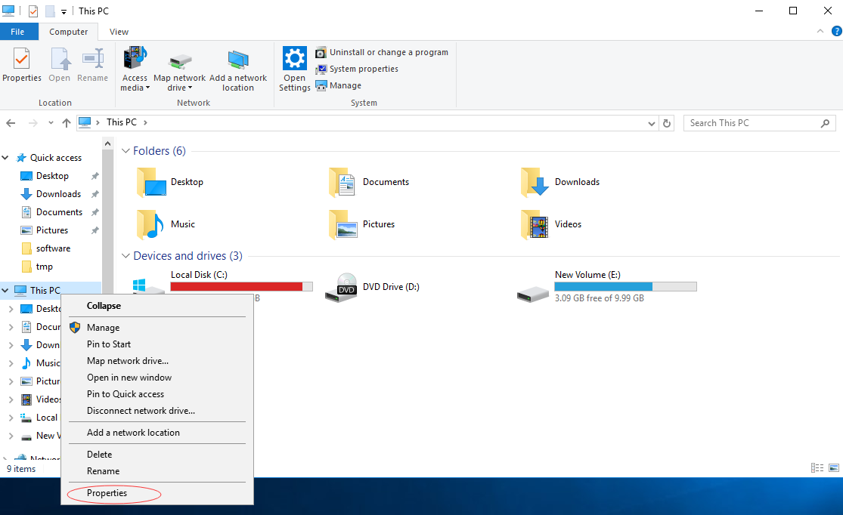

Click Advanced system settings->Advanced->Environment Variables->System variables
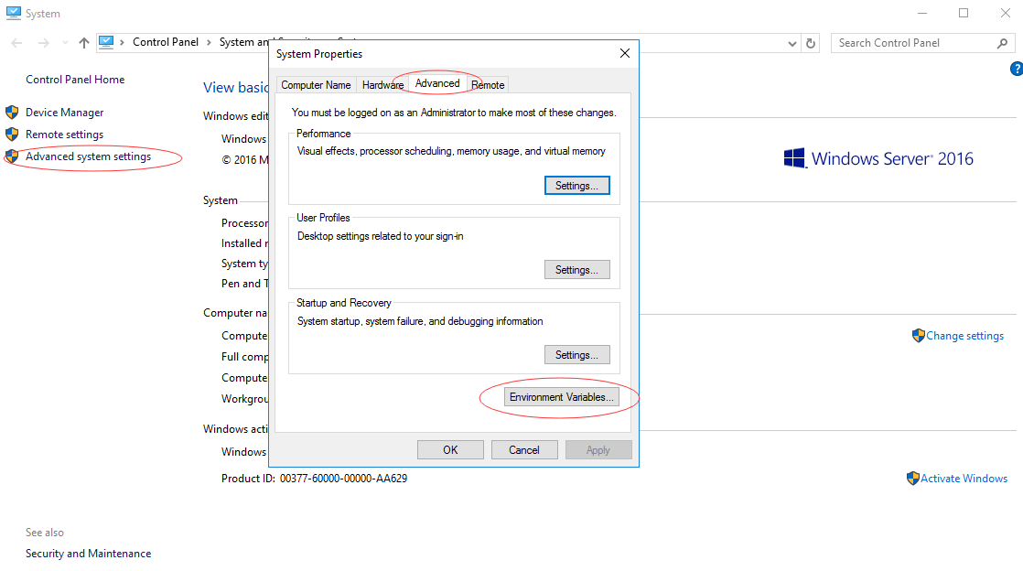

- New System Variable: JAVA_HOME
Variable name: JAVA_HOME
Variable value: C:\Program Files\Java\jdk1.8.0_201
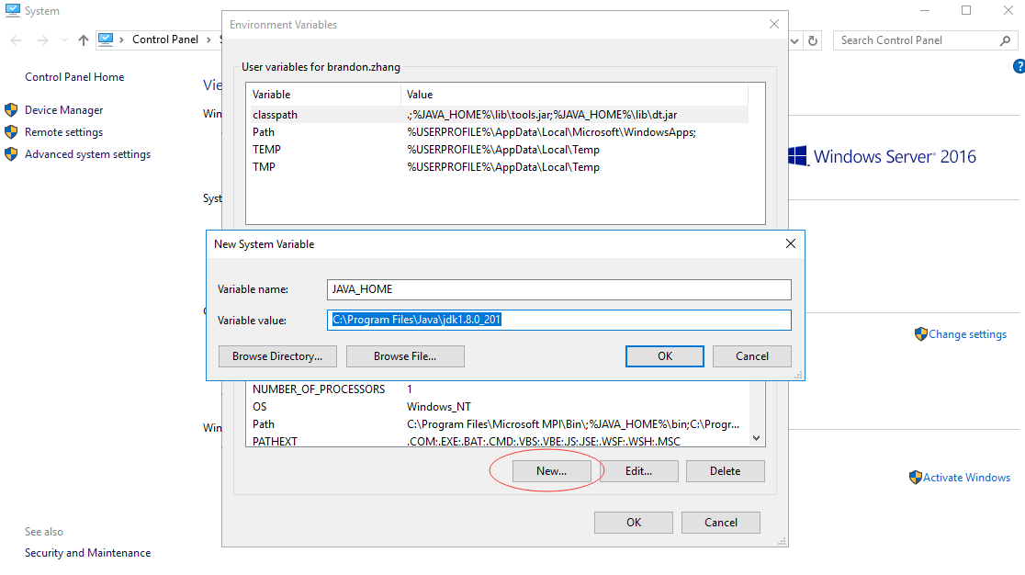

- New User variable: CLASSPATH
Variable name: CLASSPATH
Variable value: .;%JAVA_HOME%\lib;%JAVA_HOME%\lib\dt.jar;%JAVA_HOME%\lib\tools.jar;
(Note: the value is start with dot and semicolon)
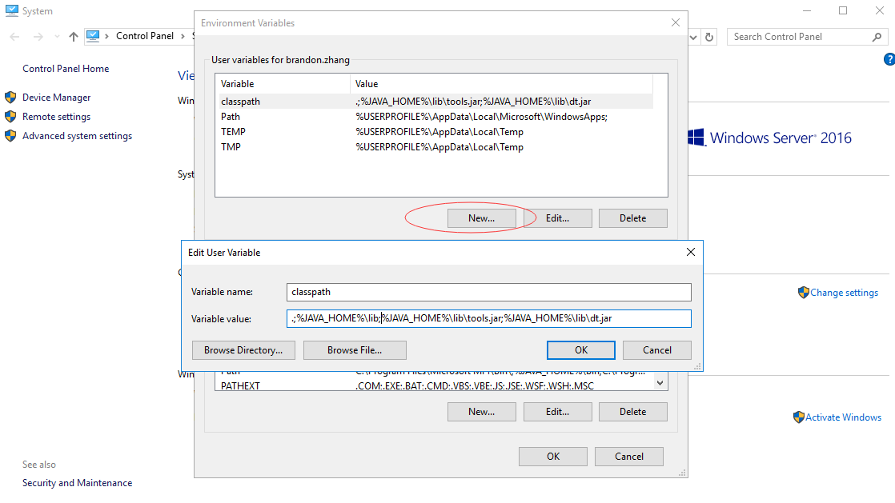

Edit system variable: Path
Find Path variable in the System variables panel -> click Edit button
Add %JAVA_HOME%\bin at the top of the variable value list
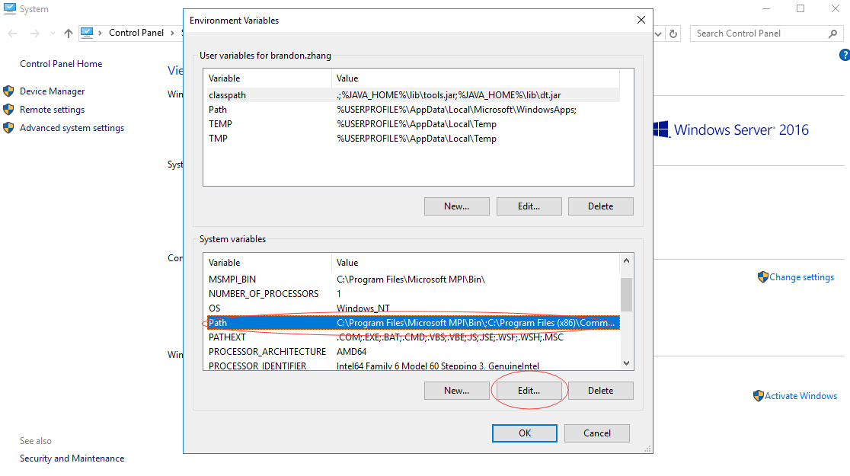

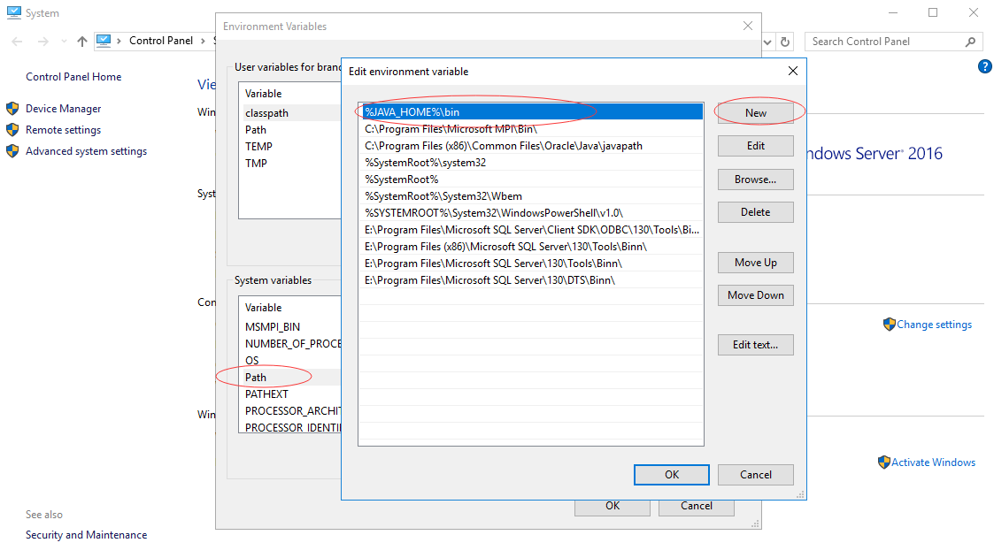

Check if the configuration is success
Run: cmd
Input : java -version
It should shows the result like the following:
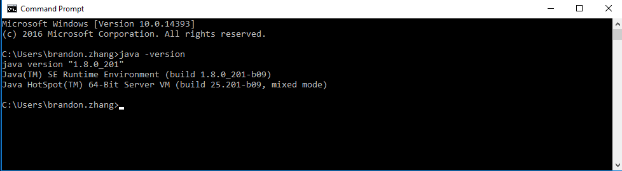

Download Tomcat server

Browser to the URL:
https://tomcat.apache.org/download-80.cgi
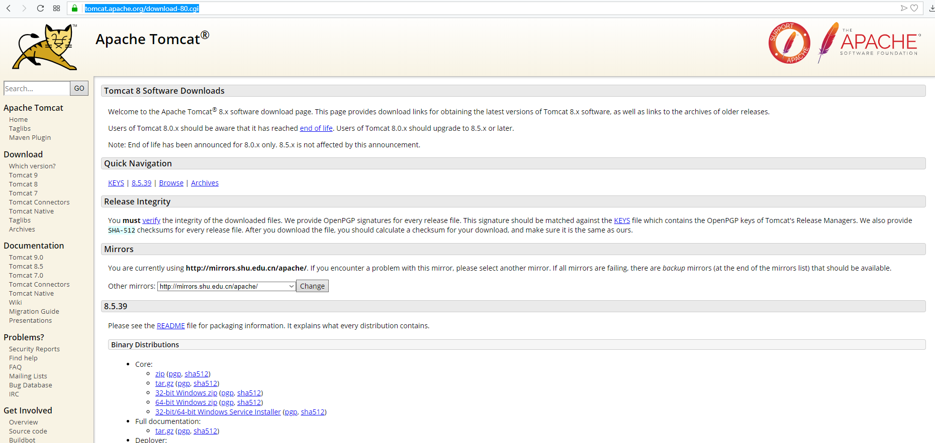

Select the 8.5.39 version with the service installer to download
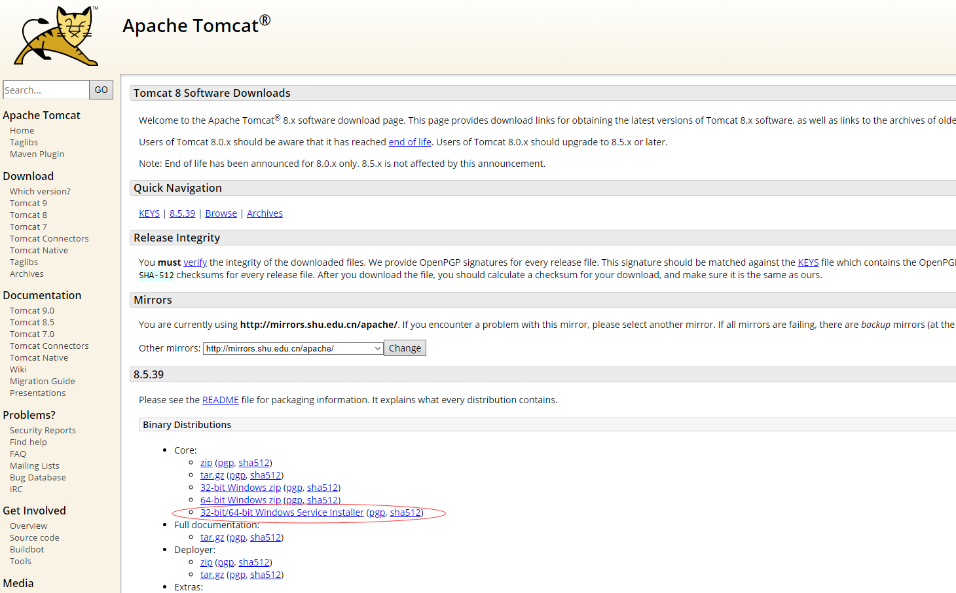

Install Tomcat Server

Run the downloaded file
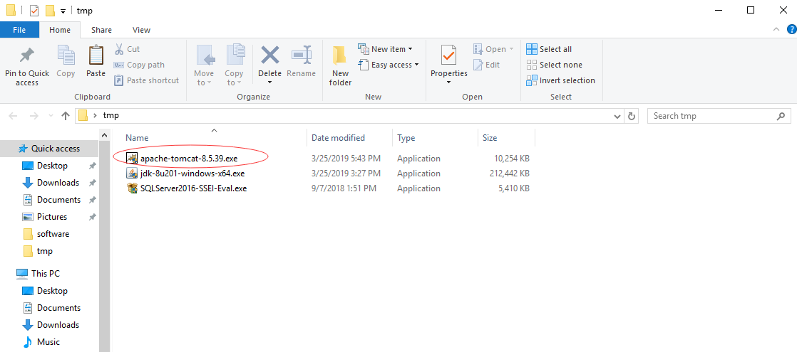

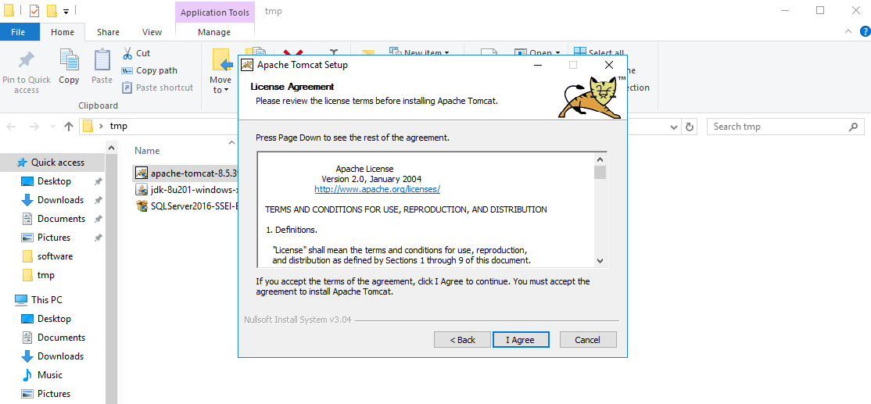

Click the next button
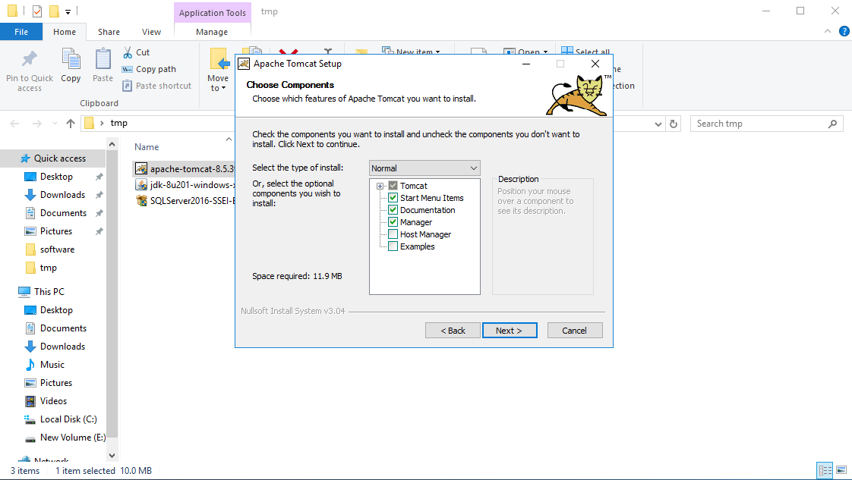

Click the next button
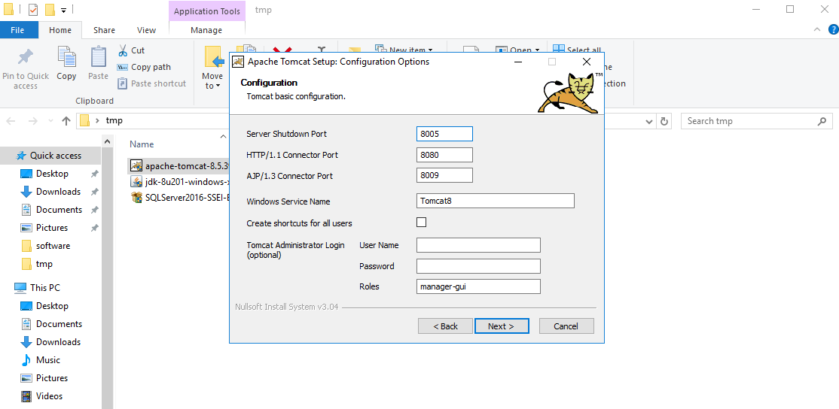

Select the path to the JDK folder
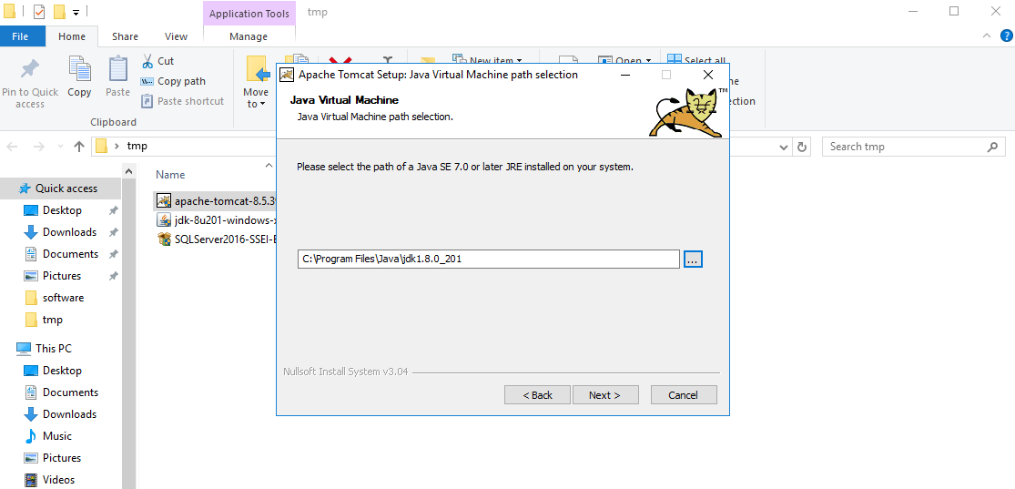

Choose install location of Tomcat, use default value and click the Install button
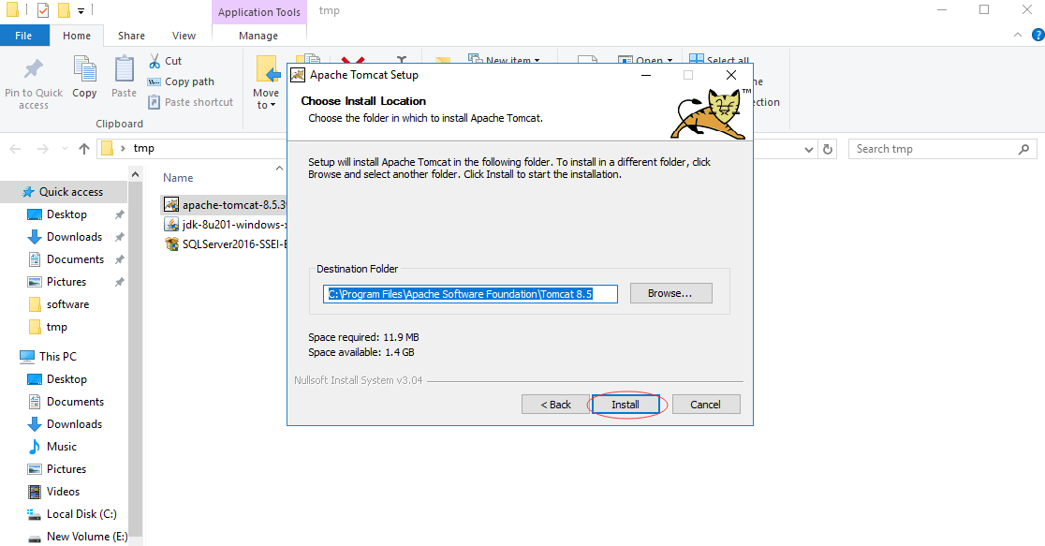

Check the option: Run Apache Tomcat and click the finish button
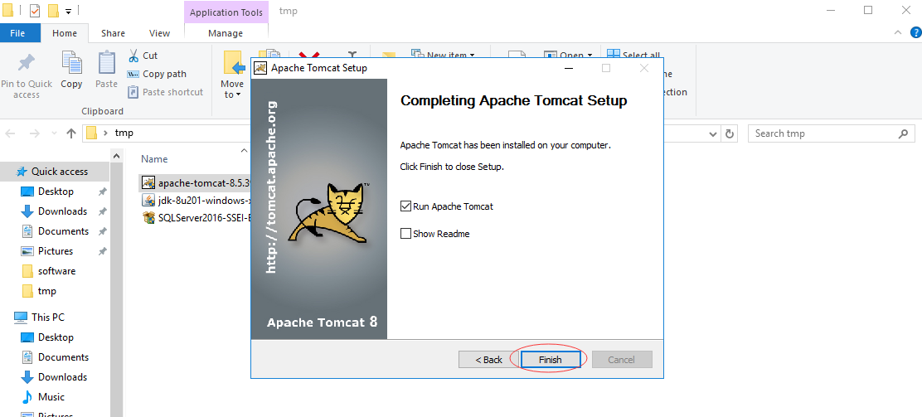

Test if the tomcat server runs successfully
Browse to the URL: http://localhost:8080
It means successful if the page shows like the followings:
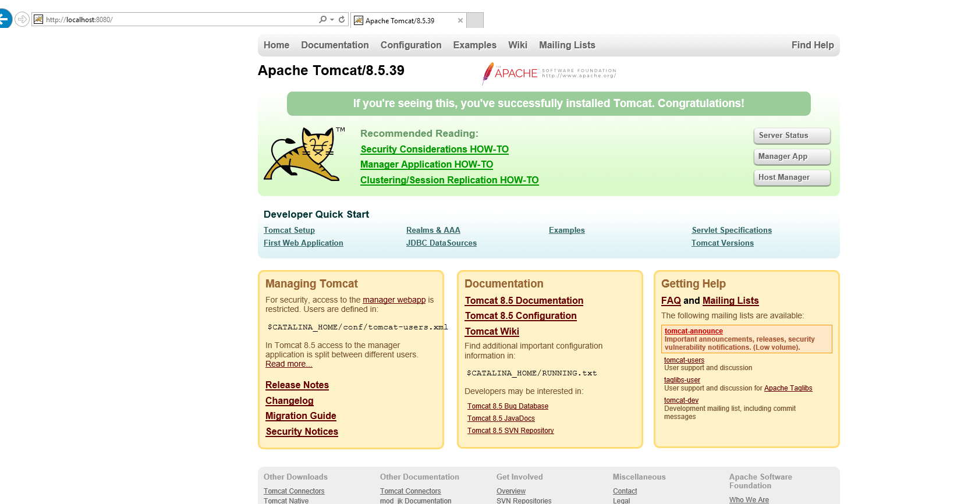

Initial Project Data
This chapter shows how to initial the database.
It requires a new database to run the following procedure.
Require data for setting data source:
No. | Item
1 | database IP
2 | database port
3 | database name
4 | username
5 | password

Note: The DB settings will be packaged into the “ROOT.war” file.

Create Schema
Please run the SQL script in the “1_CGSFSS_Schema.sql” file.
The result will look like:
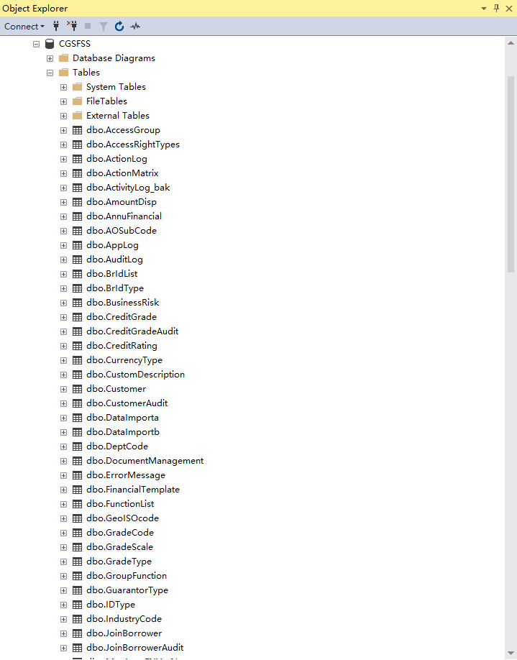

Initial table data
Please run the SQL script in the “2_CGSFSS_Data.sql” file.
The result will look like:
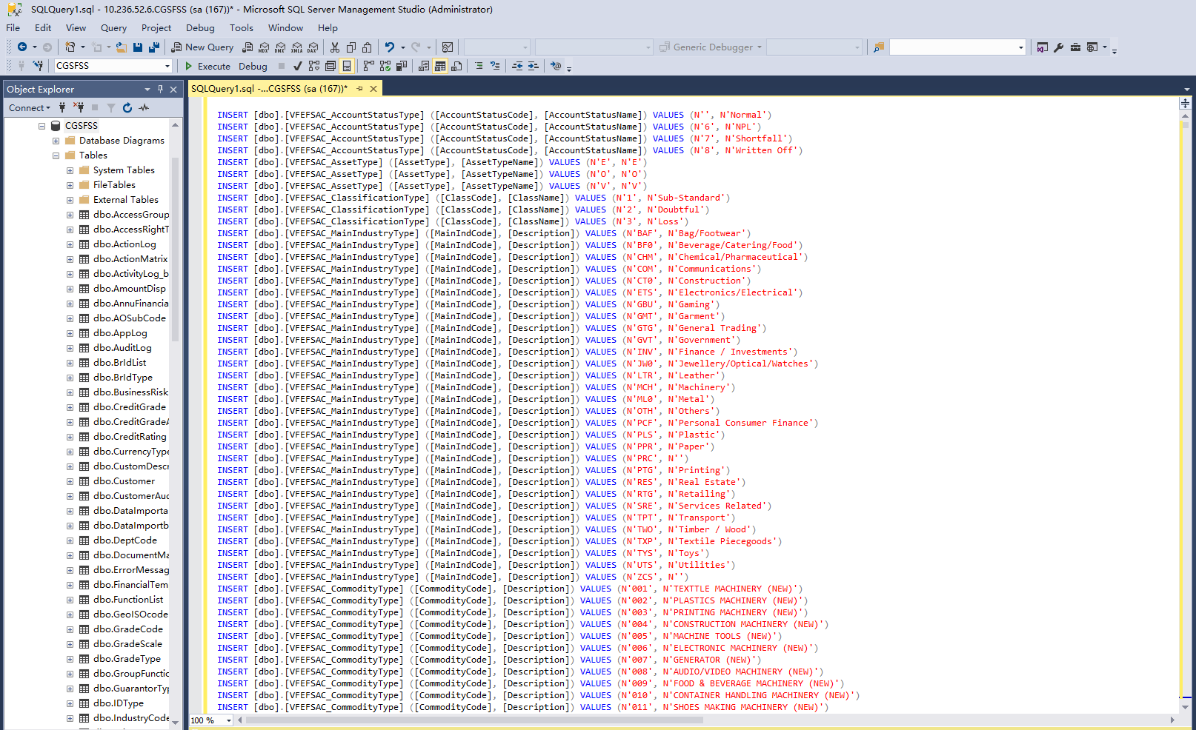

Create Trigger
Please run the SQL script in the “3_CGSFSS_Trigger.sql” file.
The result will look like:
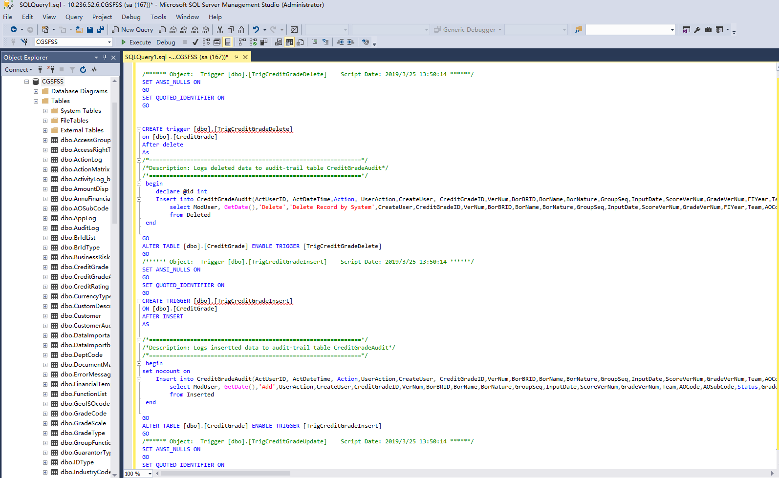

Copy file
- Copy server.xml to $Tomcat 8.5\conf\, that will overwrite the original file
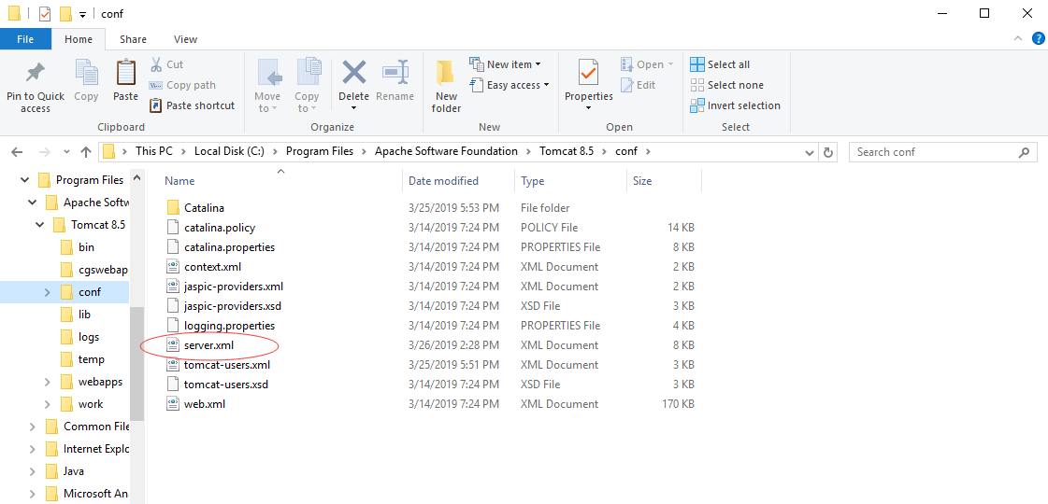

- Create new folder: cgswebapp under $Tomcat 8.5
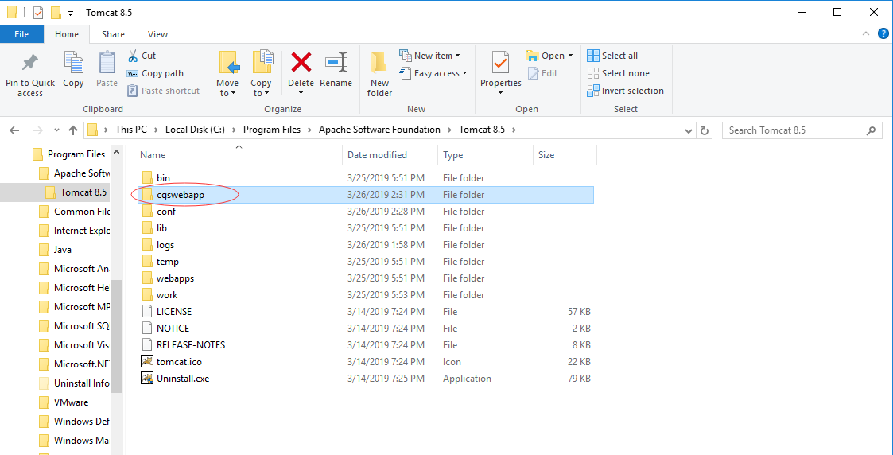

Deploy

Stop the tomcat service
- Search Services application and run it.
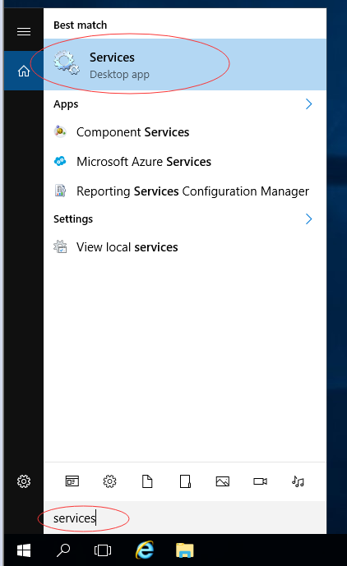

- Select tomcat service and press stop button

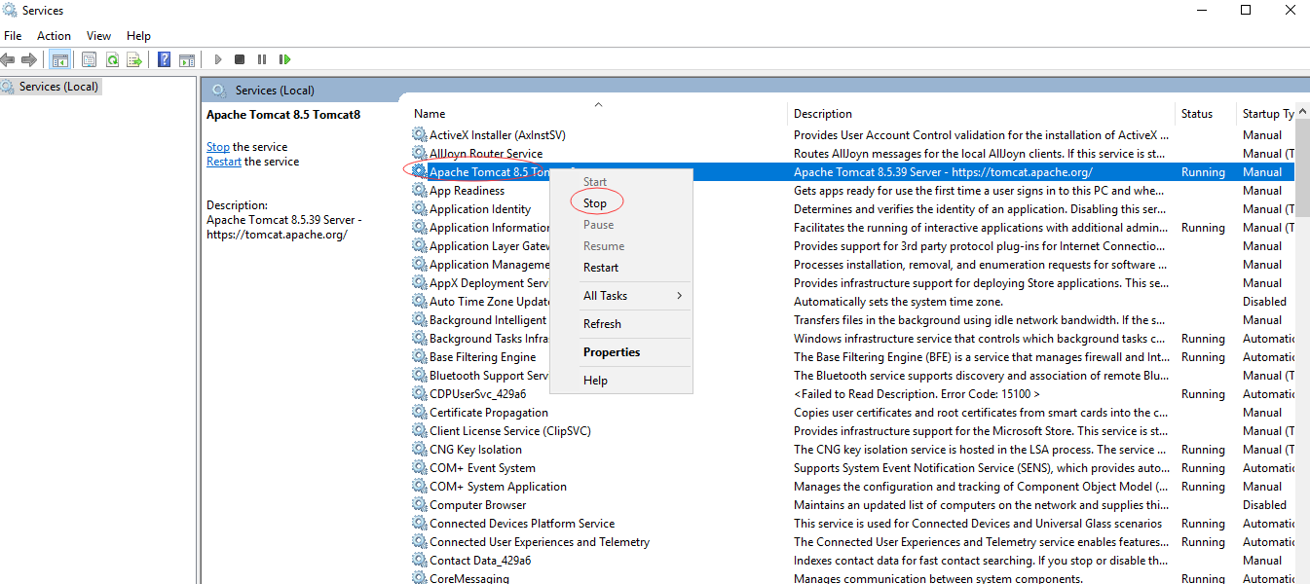

Copy deployed war
Copy the ROOT.war file to $Tomcat 8.5\cgswebapp
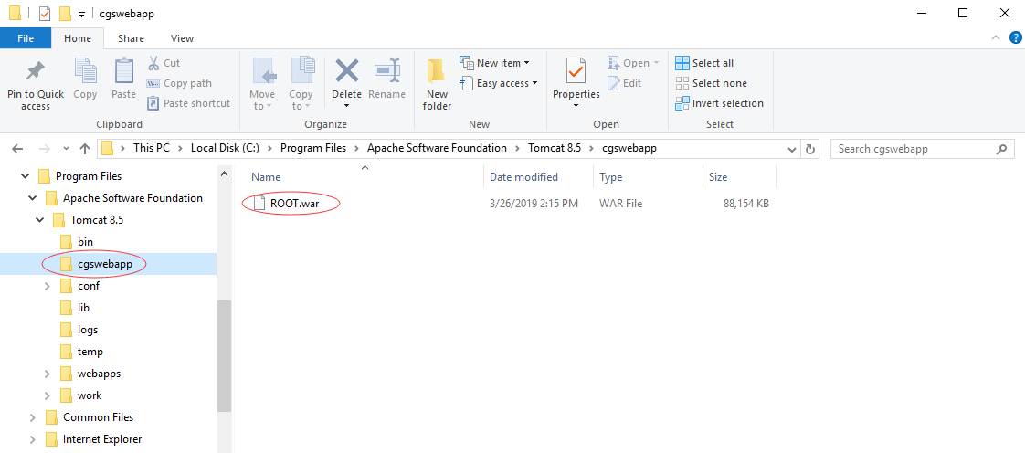

Start the tomcat service
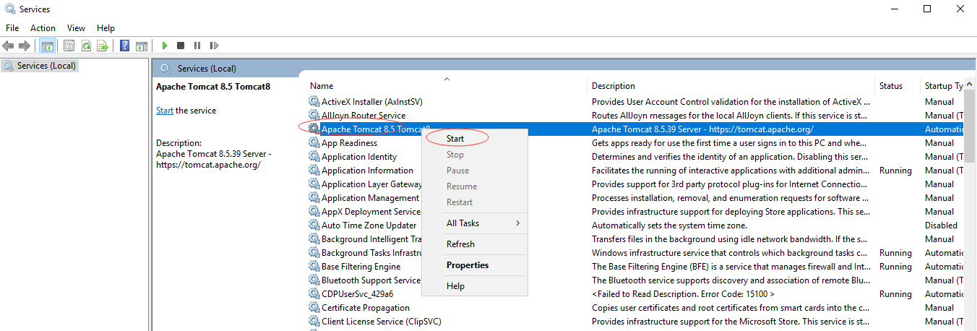

- Test if it starts success
Browse to: http://localhost or http://xxx.xxx.xxx.xxx
*Please use IE 11 or above.
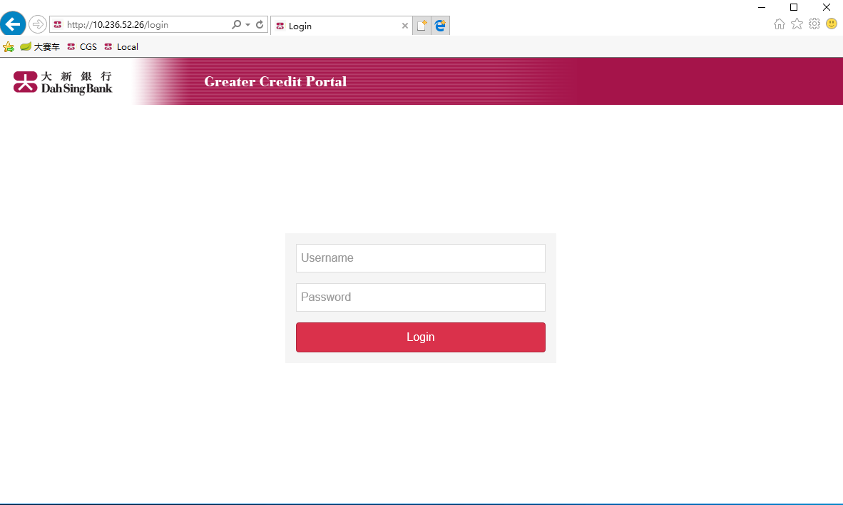

If the tomcat service starts fail, it may be cause by port conflict.
Please reference to:
http://jingyan.baidu.com/article/f96699bbca15a1894e3c1bc4.html

If you still can’t solve the issue, please zip the log file that under the folder $tomcat\logs to us.

System Login
- Default Login
Username: admin
Password: 1

- AD Login
Please refer to 7.1Set the properties for AD Login.

Re-Deploy

Update DB data
- Create schema, please reference to the chapter 3.1
- Initial table data, please reference to the chapter 3.2
- Initial triggers, please reference to the chapter 3.3

Update WAR
- Stop Apache Tomcat Service, please reference to the chapter 4.1
- Delete all the files under $Tomcat 8.5/cgswebapp
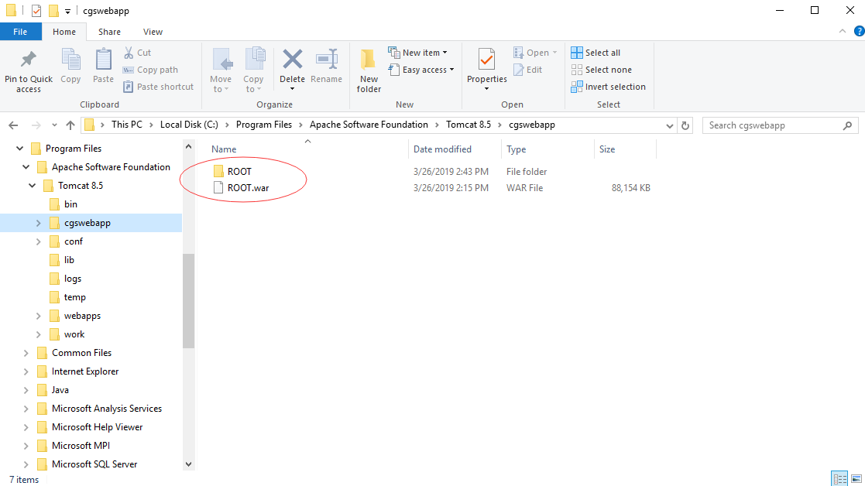

- Copy the ROOT.war to $Tomcat 8.5/cgswebapp, please reference to the chapter 4.2
- Start Apache Tomcat Service, please reference to the chapter 4.3

Deploy Schedule Applications

Deploy Monthly Report Schedule Task
- Copy the “cgs-schedule-monthlyreport.jar” to the deployment server(Window Server 2016)
- Edit the “monthlyreport.bat” file for running the “cgs-schedule-monthlyreport.jar” application

- Configure the Windows Schedule Task for starting the “ monthlyreport.bat”
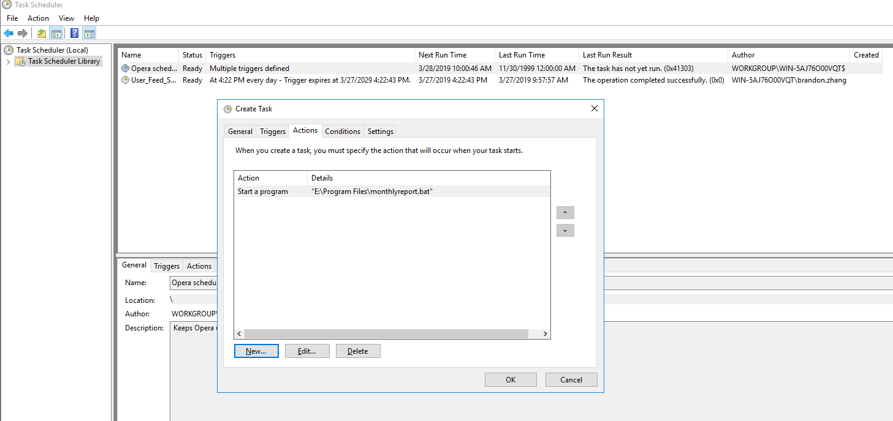

Deploy Housekeeping Schedule Task
- Copy the “cgs-schedule-housekeeping.jar” to the deployment server(Window Server 2016)
- Edit the “housekeeping.bat” file for running the “cgs-schedule-housekeeping.jar” application

- Configure the Windows Schedule Task for starting the “ housekeeping.bat”
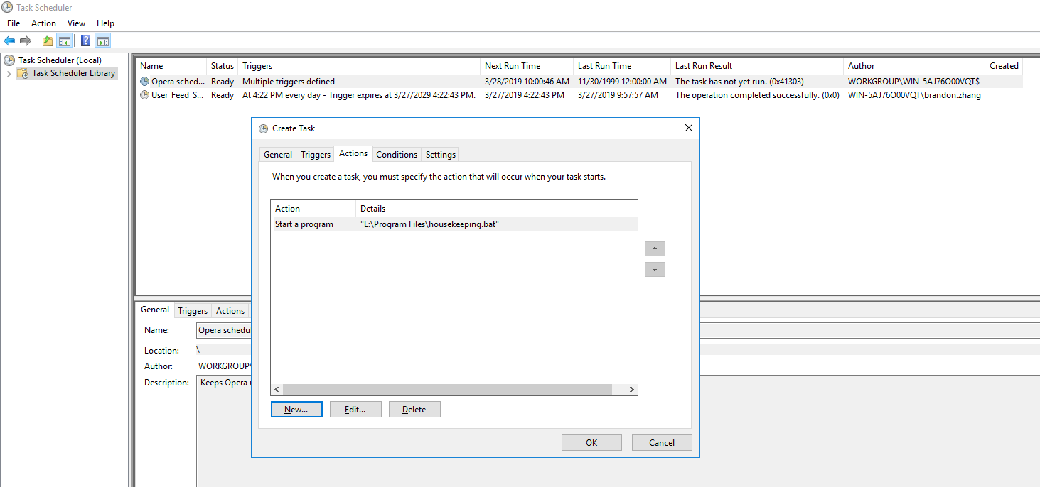

Appendix

Set the properties for AD Login
Edit the text file “ROOT.war\WEB-INF\classes\cgs.properties”
Change the following value :
-ldap.server
-ldap.username.postfix
-ldap.is.ad.login
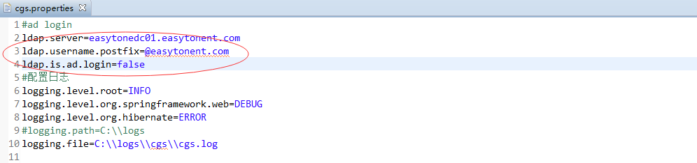

Set MS SQL Server Data Source
Edit the text file “ROOT.war\WEB-INF\classes\application.yml”
Change the following value :
-url
-username
-password
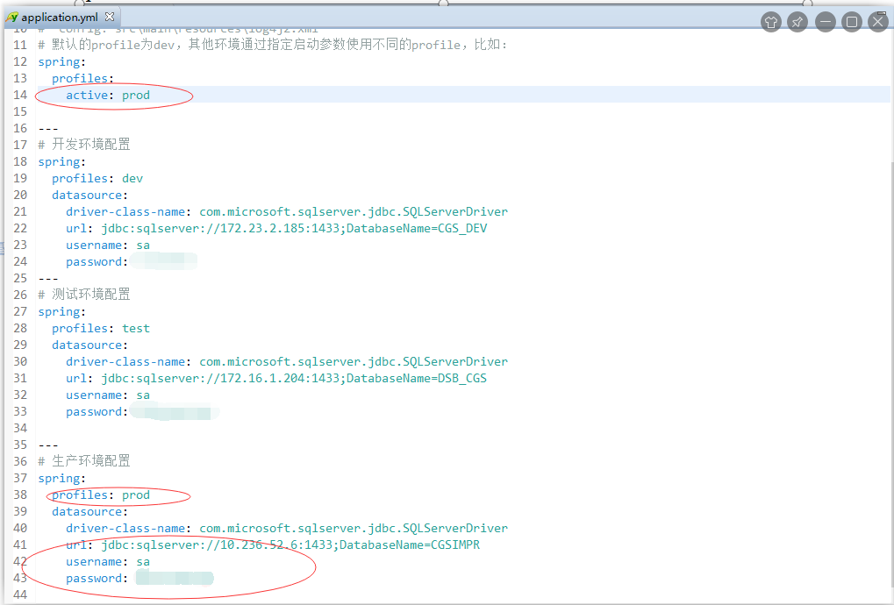

Monthly Upgrade Customer List Report Directory
- Edit the text file “ROOT.war\WEB-INF\classes\cgs.properties”
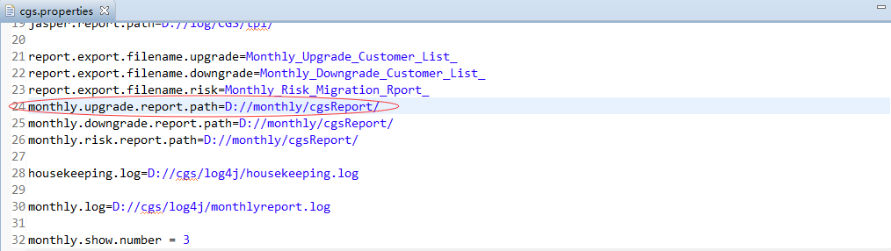

- Edit the text file “cgs-schedule-monthlyreport.jar\BOOT-INF\classes\poi.properties”
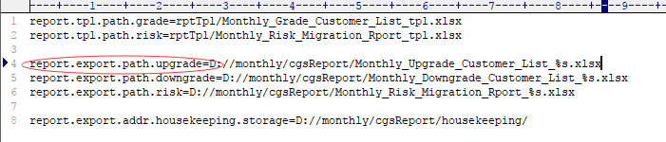

Note: The two directories must be the same.

Monthly Downgrade Customer List Report Directory
- Edit the text file “ROOT.war\WEB-INF\classes\cgs.properties”
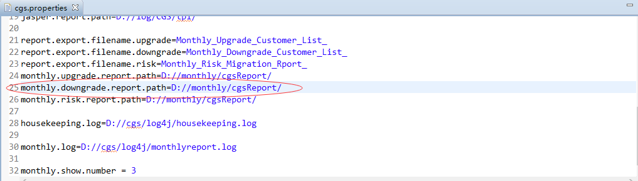

- Edit the text file “cgs-schedule-monthlyreport.jar\BOOT-INF\classes\poi.properties”
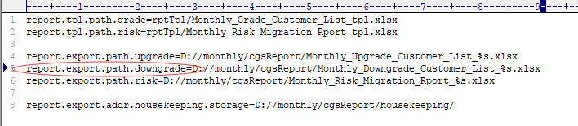

Note: The two directories must be the same.

Monthly Risk Migration Report Directory
- Edit the text file “ROOT.war\WEB-INF\classes\cgs.properties”
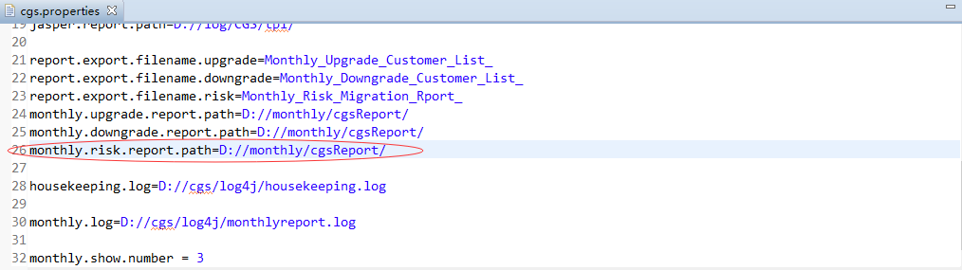

- Edit the text file “cgs-schedule-monthlyreport.jar\BOOT-INF\classes\poi.properties”
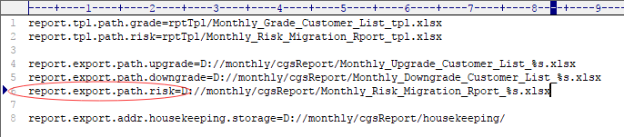

Note: The two directories must be the same.

Set Housekeeping Task directory
This directory is used to backup the deleted data by Housekeeping Task.

- Edit the text file “cgs-schedule-housekeeping.jar\BOOT-INF\classes\poi.properties”
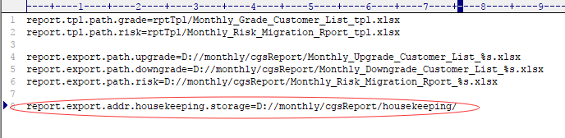

Set Housekeeping Task Running Log directory
- Edit the text file “ROOT.war\WEB-INF\classes\cgs.properties”
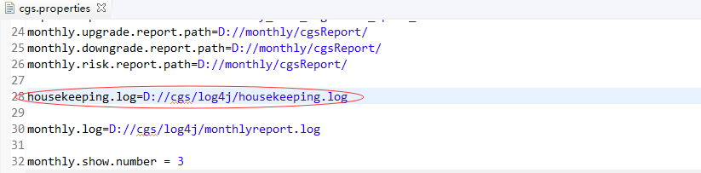

- Edit the text file “cgs-schedule-housekeeping.jar\BOOT-INF\classes\log4j.properties”
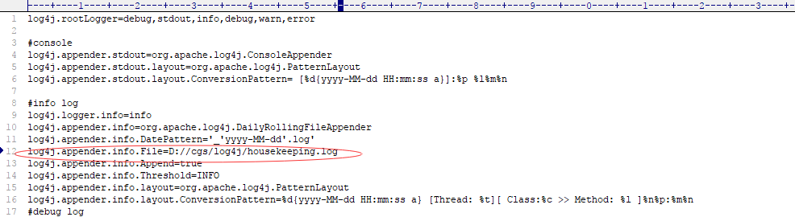

Note: The two directories and file names must be the same.

Set Monthly Report Running Log directory
- Edit the text file “ROOT.war\WEB-INF\classes\cgs.properties”
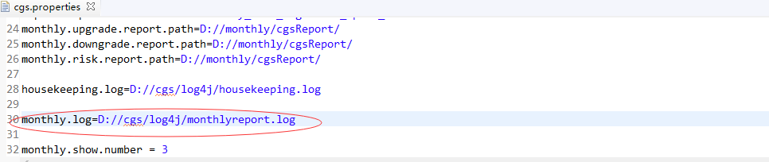

- Edit the text file “cgs-schedule-housekeeping.jar\BOOT-INF\classes\log4j.properties”
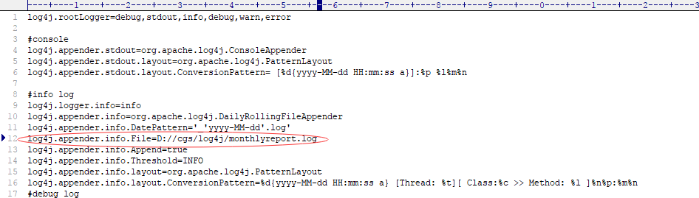

Note: The two directories and file names must be the same.

Create a new database in SQL Server 2016

Open the “Microsoft SQL Server Management Studio” and connect the DB Server:
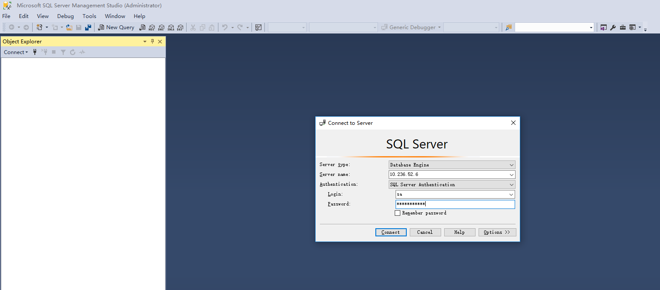

Right click the “Database” folder and select the “New Database...”
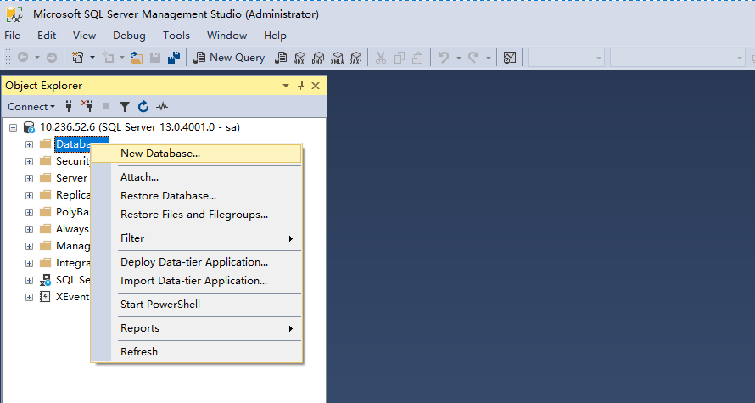
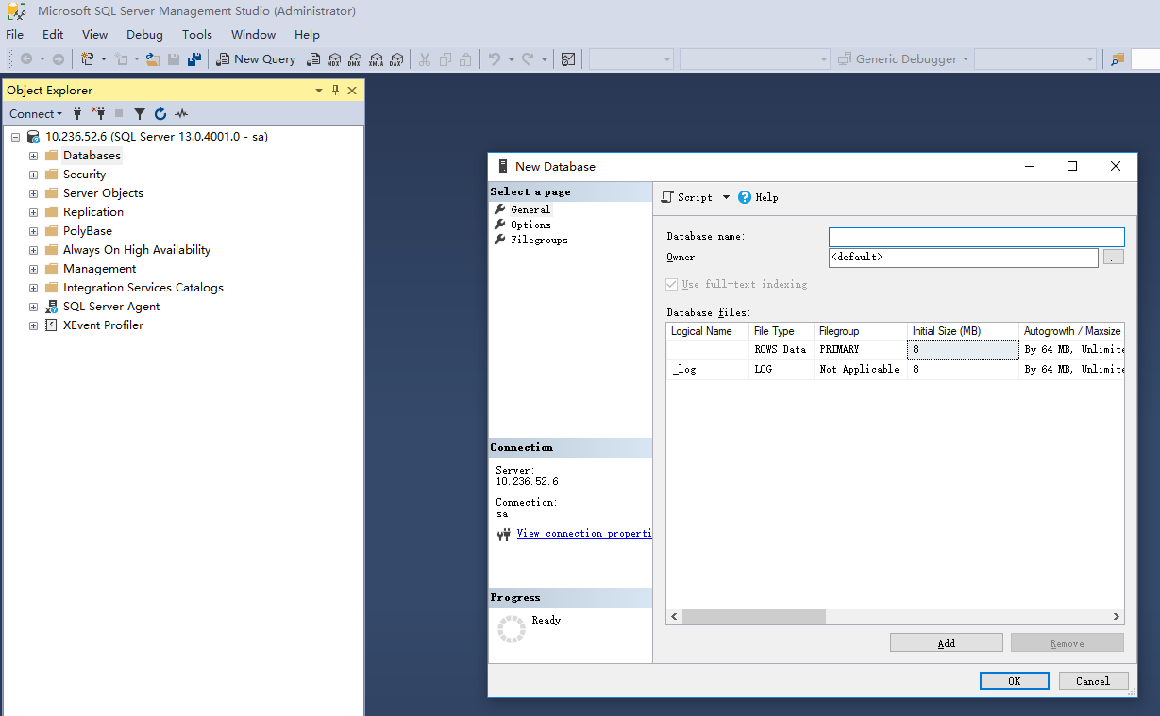

Input “Database name” and select “Collation”, then click “OK” button
